Chapter 7 – Installing Wazuh
Objective
In this chapter, we will:
- Understand the available Wazuh installation methods.
- Choose the most suitable deployment for our lab.
- Install Wazuh using the official installation assistant.
- Verify the installation.
- Access the Wazuh Dashboard.

7.1 Wazuh Installation Methods
Wazuh provides multiple deployment options depending on the organization's size and infrastructure.

Method 1 – Single Node Deployment
A Single Node deployment installs all Wazuh components on one server.
Components:
- Wazuh Manager
- Wazuh Indexer
- Wazuh Dashboard
Architecture:
Ubuntu Server
│
├── Wazuh Manager
├── Wazuh Indexer
└── Wazuh Dashboard
Advantages
- Easy to install
- Easy to manage
- Ideal for home labs
- Officially supported
- Requires only one server
Disadvantages
- Limited scalability
- Not recommended for very large organizations

Method 2 – Distributed Deployment
Each Wazuh component is installed on a separate server.
Example:
Server 1
Wazuh Manager

Server 2
Wazuh Indexer

Server 3
Wazuh Dashboard
Advantages
- High performance
- Highly scalable
- Better workload distribution
Disadvantages
- More complex
- Requires multiple servers
- Higher hardware requirements
Commonly used in:
- Enterprises
- Government
- Large Security Operations Centers (SOCs)

Method 3 – Docker Deployment
Wazuh components run inside Docker containers.
Advantages
- Fast deployment
- Portable
- Easy to recreate environments
Disadvantages
- Requires Docker knowledge
- Adds another layer of management
Suitable for:
- Developers
- Testing environments
- Container-based infrastructures

7.2 Which Installation Method Should We Choose?
For our home lab, we will use:
Single Node Deployment
Why?
Our lab consists of:
- One Ubuntu Server
- One Windows machine (Agent)
- One Kali Linux machine
- Limited hardware resources (8 GB RAM)
A Single Node installation:
- Is the simplest deployment.
- Uses fewer system resources.
- Is officially recommended for labs and learning.
- Allows us to understand all Wazuh components before moving to distributed deployments.

Chapter 7.3 – Installing Wazuh Using the Official Installation Assistant
Objective
In this chapter, we will install Wazuh on our Ubuntu Server using the official Wazuh Installation Assistant.
By the end of this chapter, you will:
- Understand the purpose of the Wazuh Installation Assistant.
- Download the installer from the official Wazuh repository.
- Learn what each command does.
- Install Wazuh using the recommended Single Node deployment.
- Verify that the installation completed successfully.
- Troubleshoot common installation issues.

7.3.1 Why Use the Wazuh Installation Assistant?
Wazuh provides an official installation script called the Wazuh Installation Assistant.
Instead of manually installing every component, this script automates the deployment using the configuration recommended by the Wazuh developers.
Without the installation assistant, an administrator would need to:
- Add Wazuh repositories.
- Install the Wazuh Manager.
- Install the Wazuh Indexer.
- Install the Wazuh Dashboard.
- Generate SSL/TLS certificates.
- Configure communication between components.
- Configure services.
- Start each service manually.
This process requires many commands and increases the chance of configuration mistakes.
The Installation Assistant simplifies the deployment by automating these tasks.

Why Do We Use the Official Installer?
There are several advantages to using the official installation assistant:
- Officially supported by the Wazuh team.
- Faster installation.
- Fewer configuration errors.
- Uses recommended settings.
- Easier to troubleshoot using official documentation.
- Suitable for beginners and production administrators.
For our home lab, we will use this method because it is the simplest and most reliable.

7.3.2 Downloading the Installation Assistant
The installer is distributed as a Bash script and can be downloaded directly from the official Wazuh package repository.
Command
curl -sO https://packages.wazuh.com/4.14/wazuh-install.sh
Note: The version number (4.14) may change in the future. Always verify the latest supported version in the official Wazuh documentation before downloading.

Understanding the Command
curl
A command-line tool used to download data from servers.
Here, it downloads the Wazuh installation script.

-s
Silent Mode
Suppresses unnecessary output while downloading.

-O
Uppercase letter O
Saves the downloaded file using its original filename.
The downloaded file will be:
wazuh-install.sh

URL
https://packages.wazuh.com/4.14/wazuh-install.sh
This is the official Wazuh package repository.
Always download installation files from official sources.

7.3.3 Verify the Download
After downloading the script, verify that it exists.
Command
ls -l
Expected output:
wazuh-install.sh

Why Verify?
Before executing any downloaded script:
- Confirm the file exists.
- Ensure the download completed successfully.
- Avoid running incomplete or corrupted files.
This is considered a good security practice.

7.3.4 Make the Script Executable
By default, downloaded scripts may not have execute permission.
Grant execute permission using:
chmod +x wazuh-install.sh

Understanding the Command
chmod
Changes file permissions.
+x
Adds execute permission.
After this command, Linux allows the script to run.

7.3.5 Verify Execute Permission
Check the file permissions.
ls -l wazuh-install.sh
You should see an x in the permission field.
Example:
-rwxr-xr-x
The x indicates that the file is executable.

7.3.6 Understanding the Installer Options
Before running the installer, view the available options.
Command
./wazuh-install.sh --help
This displays all supported installation modes.
For our home lab, the important option is:
-a, --all-in-one
This installs:
- Wazuh Manager
- Wazuh Indexer
- Wazuh Dashboard
on the same Ubuntu Server.

Why Are We Using -a?
Our lab consists of:
- One Ubuntu Server
- One Windows client
- One Kali Linux machine
A Single Node deployment is ideal because:
- It requires fewer resources.
- It is easier to manage.
- It is recommended for learning and home labs.
- All Wazuh components run on one server.

Chapter 7.4 – Installing Wazuh (Single Node Deployment)
Objective
In this chapter, we will install all Wazuh components on a single Ubuntu Server using the Official Wazuh Installation Assistant.
By the end of this chapter, you will have:
- Wazuh Manager
- Wazuh Indexer
- Wazuh Dashboard
installed on one server.

7.4.1 Before Installing
Before starting the installation, verify the following:
✅ Ubuntu Server installed
✅ Internet connection working
ping google.com
✅ System updated
sudo apt update
sudo apt upgrade -y
✅ Installation Assistant downloaded
ls
You should see:
wazuh-install.sh

7.4.2 Understanding Installation Types
The Installation Assistant supports multiple deployment methods.
For our home lab, we will use:
Single Node Deployment
This installs:
Ubuntu Server
│
├── Wazuh Manager
├── Wazuh Indexer
└── Wazuh Dashboard
Everything runs on one machine.

7.4.3 Start the Installation
Run:
sudo ./wazuh-install.sh -a
or
sudo ./wazuh-install.sh --all-in-one
Both commands perform the same operation.
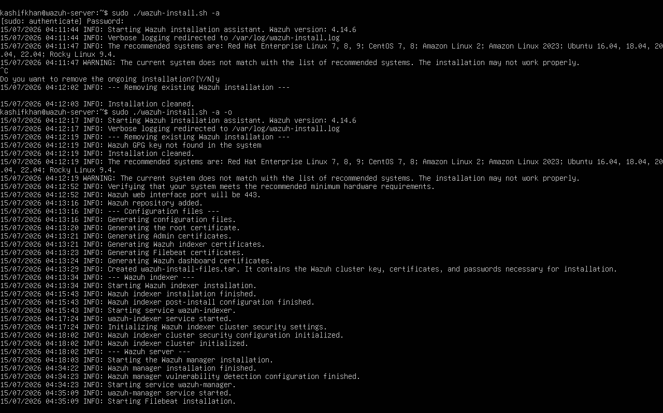

Understanding the Command
sudo
Runs the installer with administrator privileges.
Installing Wazuh requires permission to:
- Install software packages
- Modify system configuration
- Create system users
- Configure services
- Generate certificates

./
Runs a program located in the current directory.
Without ./, Linux searches only the directories listed in the system's PATH variable.

wazuh-install.sh
The official Wazuh Installation Assistant downloaded from the Wazuh package repository.

-a (All-in-One)
Installs:
- Wazuh Manager
- Wazuh Indexer
- Wazuh Dashboard
on the same server.
This is the recommended deployment method for:
- Home Labs
- Students
- Testing environments
- Small organizations

What Happens During Installation?
The installer performs many tasks automatically.
These include:
1. Verify System Requirements
Checks:
- CPU
- RAM
- Disk space
- Operating System

2. Install Required Packages
Downloads all required software from the official repositories.
Examples include:
- Java
- OpenSearch
- Filebeat
- Wazuh packages

3. Generate SSL/TLS Certificates
Creates certificates used to encrypt communication between:
- Manager
- Indexer
- Dashboard
This ensures secure communication between Wazuh components.

4. Configure Services
The installer automatically configures:
- Wazuh Manager
- Wazuh Indexer
- Wazuh Dashboard
It also creates the required configuration files.

5. Start Services
Once installation is complete, Linux starts the Wazuh services.
These services are also configured to start automatically after system reboot.

Installation Time
The installation duration depends on:
- Internet speed
- CPU
- RAM
- Disk speed
Approximate time:
Hardware | Time
SSD + Good Internet | 15–20 Minutes
HDD | 20–35 Minutes
Slow Internet | 30–45 Minutes

Important Note About Wazuh Versions
Different Wazuh versions may use slightly different installation workflows.
Always compare the commands in this handbook with the official Wazuh documentation for the version you are installing.
If the installer has changed, follow the updated official instructions.

Real Lab Experience (Our Installation)
During our installation, we encountered several issues that are useful learning experiences.
Issue 1 – Configuration File Error
When we ran:
sudo ./wazuh-install.sh --generate-config-files
the installer returned:
ERROR: No configuration file found.
Reason:
In Wazuh 4.14, the --generate-config-files option expects a config.yml file to already exist. It is intended for generating deployment files for certain installation scenarios, not for creating the configuration itself.
Solution:
For a Single Node Home Lab, use the -a (--all-in-one) installation option instead of generating configuration files first.

Issue 2 – Unsupported Operating System Warning
The installer displayed:
WARNING:
The current system does not match the list of recommended systems.
Reason:
Our lab used Ubuntu Server 24.04, while the installer officially listed support up to Ubuntu Server 22.04.
Important:
This is a warning, not necessarily an installation failure. However, using a supported LTS version is recommended for the best compatibility.

Issue 3 – Partial Installation
When running the installer again, it reported:
ERROR:
Wazuh manager already installed.
Wazuh indexer already installed.
After verification, we found:
Component | Status
Wazuh Manager | Installed but not running
Wazuh Indexer | Running
Wazuh Dashboard | Not installed
This indicated a partial installation, meaning some components were installed while others were not.
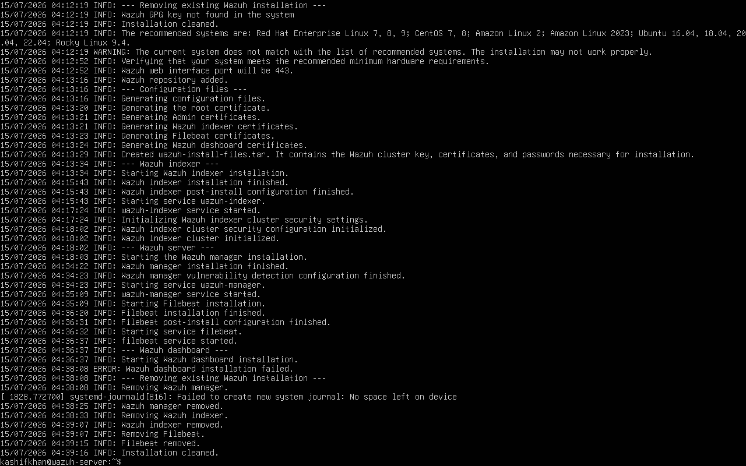

Lesson Learned:
Before using the --overwrite option, always check:
dpkg -l | grep wazuh
and verify the service status using:
sudo systemctl status wazuh-manager
sudo systemctl status wazuh-indexer
sudo systemctl status wazuh-dashboard
Understanding the current installation state helps determine whether to troubleshoot the existing installation or perform a clean reinstall.

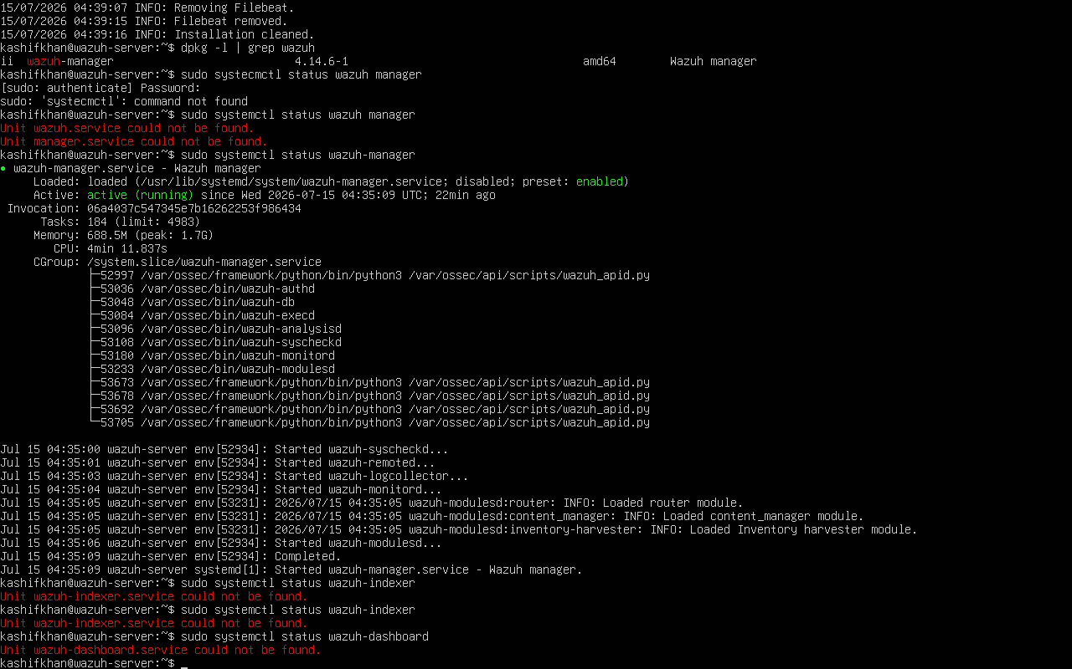

After seeing the "No space left on device" error, the correct action is not to continue troubleshooting Wazuh itself. Instead:
- Check available disk space:
df -h
free -h
- Free up space or increase the virtual disk size.
- Perform a clean installation again.

Lesson Learned
This experience highlights an important troubleshooting principle:
Never assume the installation succeeded just because the installer ran. Always verify the status of each component after installation.

